Brain Tumor Detection System
Structural Modeling

Package Diagram, Class Diagram, Enumeration Types, and Folder Structure

Graduation Project — 2026

Table of Contents

1. Structural Modeling Overview
Structural modeling describes the static structure of the system — how classes, packages, and types are organized and relate to each other. Unlike behavioral modeling (which shows how the system acts over time), structural modeling shows what the system is made of.
This document contains 3 diagrams:
- Package diagram — shows how code is organized into 5 logical packages (frontend, backend, ai_service, database, shared) with their sub-modules and dependencies
- Class diagram — shows 8 domain model classes with attributes, methods, inheritance, and associations (from the Data Modeling document, referenced here for completeness)
- Enumeration types diagram — shows all 11 custom ENUM types with their allowed values

Together, these three diagrams give developers a complete picture of the codebase structure before writing any code. The package diagram tells them where to put files, the class diagram tells them what objects to build, and the enumeration diagram tells them what constrained values to use.

2. Package Diagram
The package diagram organizes the entire codebase into 5 top-level packages, each representing a deployable service or shared library. Dependencies between packages are shown as dashed «use» arrows — the arrow points from the dependent package to the package it uses.

2.1 frontend (React)
The React single-page application. Contains 7 sub-modules:
- pages/ — 10 route-level components: Landing, Login, Register, IntakeForm, MRIUpload, Results, PatientDashboard, DoctorDashboard, AdminPanel, SharedResults
- components/ — reusable UI pieces: TriageBanner, MRIPanel, DoctorCard, NotificationBell, LoadingAnimation, IntakeStep, etc.
- services/ — API client layer using axios. Centralizes all HTTP calls to the Node.js backend (e.g., scanService.upload(), authService.login())
- context/ — React Context providers for AuthContext (JWT + user state), ThemeContext (dark/light mode), and LanguageContext (Arabic/English)
- hooks/ — custom React hooks: useAuth(), useScans(), useNotifications(), useConsultation()
- i18n/ — translation files for Arabic and English using i18next or react-intl
- utils/ — shared helpers, date formatters, triage color constants, file validation functions

2.2 backend (Node.js + Express)
The API gateway server. Contains 9 sub-modules:
- controllers/ — route handler logic organized by domain: AuthController, PatientController, DoctorController, AdminController, ConsultationController, MessageController
- routes/ — Express Router definitions mapping HTTP methods and paths to controllers
- middleware/ — cross-cutting concerns: JWT verification, role-based access check (RBAC), file upload handling (Multer), session timeout, error handler
- models/ — ORM entity definitions (Sequelize models or Mongoose schemas) for all 8 database tables
- services/ — business logic layer. ScanOrchestrator (forwards to FastAPI), NotificationService (creates and delivers notifications), ConsultationService
- validators/ — request body validation schemas using Joi or Zod. Ensures intake form data, registration fields, and clinical notes meet constraints before reaching the database
- config/ — environment configuration: database connection strings, JWT secret and expiry, FastAPI URL, file upload limits
- utils/ — shared helpers: password hashing, token generation, share link creation, response formatting
- migrations/ — database migration files for schema versioning and seed data for development

2.3 ai_service (Python FastAPI)
The stateless AI prediction microservice. Contains 5 sub-modules:
- api/ — the single /predict endpoint definition with request/response schemas
- models/ — model loading and inference code for CNN classifier, U-Net segmenter, and treatment suggestion model
- preprocessing/ — MRI image transformation pipeline: resize, normalize, convert to model-ready array
- postprocessing/ — result extraction: get_tumor_location() centroid mapping, tumor size calculation from mask pixels, hemisphere detection
- weights/ — saved model weight files (.h5, .pt, .pkl) loaded into memory on server startup

2.4 database
The persistence layer. Contains 3 sub-modules:
- tables/ — 8 entity tables: Users, PatientProfiles, DoctorProfiles, Scans, Consultations, Messages, Notifications, DoctorRatings
- indexes/ — 11 performance indexes optimizing common queries (scan history, notification count, doctor search)
- file_storage/ — disk or blob storage for MRI images, segmentation masks, and doctor license documents

2.5 shared / common
Shared types and constants used by multiple packages. Contains 4 sub-modules:
- enums/ — 11 enumeration type definitions (Role, Gender, TriageTier, etc.) shared between frontend validation and backend models
- errors/ — standardized error code definitions and error response format
- types/ — DTO (Data Transfer Object) shapes: ScanResultDTO, ConsultationDTO, UserProfileDTO
- constants/ — triage color hex codes (#D32F2F, #E65100, #1B7D3A), validation rules (password requirements, file size limits), and other shared values

2.6 Dependencies
The package diagram shows three «use» dependency arrows:
- frontend → backend: React calls Node.js REST endpoints via axios
- backend → ai_service: ScanOrchestrator forwards MRI + features to FastAPI via internal HTTP
- backend → database: ORM models read/write to PostgreSQL/MongoDB
- frontend, backend, ai_service → shared: all three services reference shared enum definitions and constants

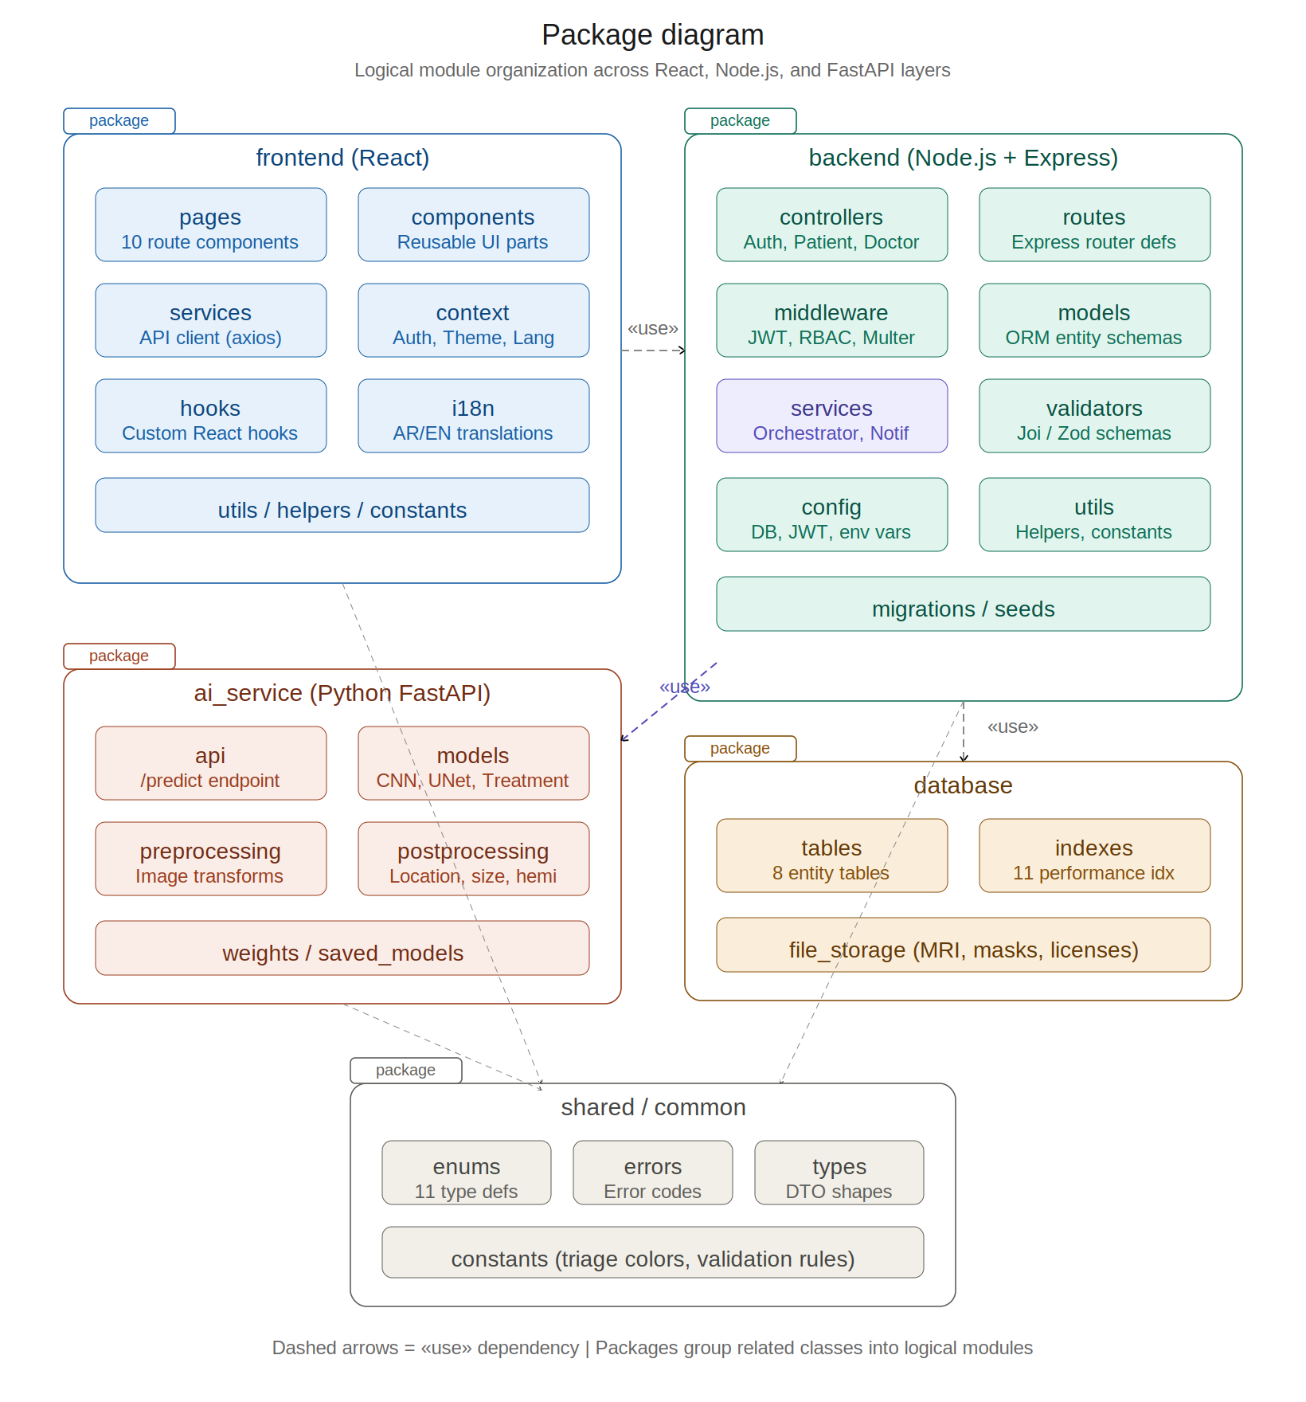
Figure 2.1 — Package diagram

3. Class Diagram
The class diagram (fully documented in the Data Modeling section) shows the 8 domain model classes with their attributes, methods, and relationships. It is included here for structural completeness.

Key structural decisions:
- Inheritance: User is an abstract base class. Patient and Doctor extend User, inheriting shared properties (id, email, password_hash, name, role) and shared methods (register, login, resetPassword, deactivate). This avoids attribute duplication and enforces a single Users table with a role discriminator.
- Composition vs Association: Scan belongs to Patient (composition — deleting a patient should cascade to their scans). Consultation is associated with both a Scan and a Doctor (association — neither owns the other exclusively). Message belongs to Consultation (composition — messages cannot exist outside a consultation).
- Visibility: All attributes use private visibility (–) to enforce encapsulation. Methods use public visibility (+) as they define the class interface. In practice, ORM frameworks expose getters/setters, but the design intent is to route all data access through methods.

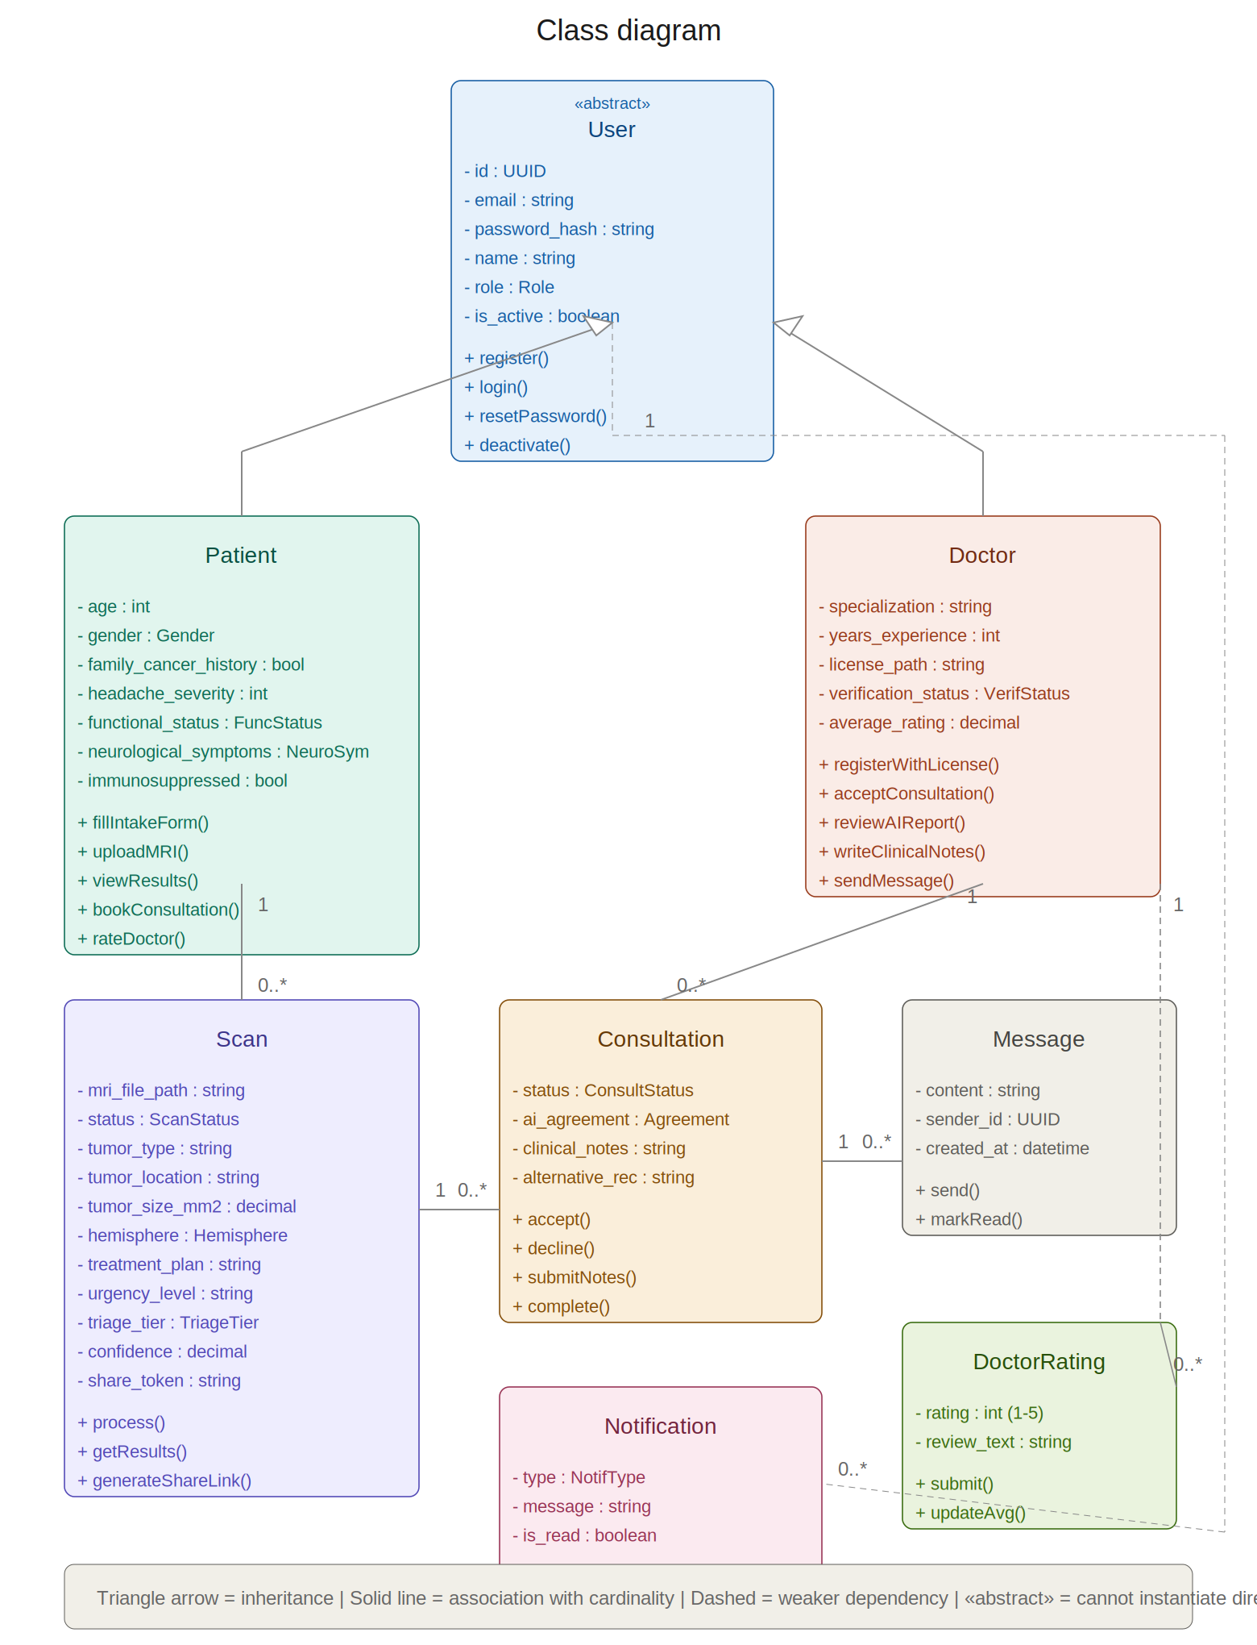
Figure 3.1 — Class diagram

4. Enumeration Types Diagram
This diagram shows all 11 custom enumeration types used across the domain model. Each «enumeration» stereotype defines a closed set of allowed values. These types are defined once in the shared/common package and referenced by both the frontend (for form dropdowns and validation) and the backend (for database constraints and API validation).

4.1 Patient-Related Enums
- Role (patient | doctor | admin) — determines which UI and API endpoints a user can access
- Gender (male | female) — input feature for the treatment suggestion model
- FunctionalStatus (independent | needs_some_help | needs_significant_help | fully_dependent) — plain-language proxy replacing the clinical KPS score. Mapped to numeric values before feeding to the ML model
- NeurologicalSymptoms (none | mild | moderate | severe) — proxy replacing the neurological deficit examination. Patient self-reports severity level

4.2 Scan-Related Enums
- ScanStatus (created | processing | completed | failed) — tracks the scan lifecycle. See state diagram ST-01 in Behavioral Modeling
- Hemisphere (left | right) — determined from the segmentation mask centroid x-position relative to image center
- TriageTier (emergency | urgent | routine) — ML model output. Maps to strict color codes: emergency = #D32F2F (red), urgent = #E65100 (amber), routine = #1B7D3A (green). These colors must NEVER be used decoratively elsewhere in the UI

4.3 Consultation-Related Enums
- VerificationStatus (pending | verified | rejected) — controls whether a doctor appears in patient search results. Only verified doctors can receive consultation requests
- ConsultationStatus (pending | accepted | declined | in_progress | completed) — tracks the consultation lifecycle. See state diagram ST-02
- AgreementLevel (agree | partially_agree | disagree) — doctor’s assessment of the AI suggestion accuracy. Required when submitting clinical notes. If partially_agree or disagree, the alternative_recommendation field becomes required

4.4 System Enums
- NotificationType (scan_completed | consult_requested | consult_accepted | consult_declined | notes_available | new_message | doctor_verified) — determines the notification icon, message template, and navigation target when clicked

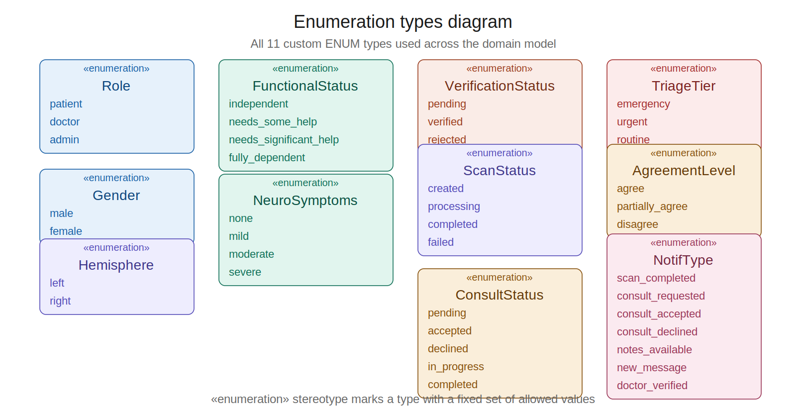
Figure 4.1 — Enumeration types diagram

5. Recommended Folder Structure
Based on the package diagram, here is the recommended folder structure for the three services:

5.1 React Frontend
Path | Contents
src/ | Root source directory
src/pages/ | 10 route components (Landing, Login, Register, etc.)
src/components/ | Reusable components (TriageBanner, MRIPanel, DoctorCard)
src/components/common/ | Generic UI (Button, Modal, Input, Spinner)
src/services/ | API client modules (authService, scanService, consultationService)
src/context/ | AuthContext, ThemeContext, LanguageContext providers
src/hooks/ | useAuth, useScans, useNotifications custom hooks
src/i18n/ | ar.json and en.json translation files
src/utils/ | Formatters, validators, triage color constants
src/styles/ | Global CSS, Tailwind config, dark mode variables
public/ | Static assets, favicon, index.html

5.2 Node.js Backend
Path | Contents
src/ | Root source directory
src/controllers/ | auth.controller.js, patient.controller.js, doctor.controller.js, admin.controller.js, consultation.controller.js, message.controller.js
src/routes/ | auth.routes.js, patient.routes.js, doctor.routes.js, admin.routes.js, consultation.routes.js
src/middleware/ | auth.middleware.js (JWT verify), rbac.middleware.js (role check), upload.middleware.js (Multer), error.middleware.js
src/models/ | User.js, PatientProfile.js, DoctorProfile.js, Scan.js, Consultation.js, Message.js, Notification.js, DoctorRating.js
src/services/ | scan.orchestrator.js, notification.service.js, consultation.service.js
src/validators/ | auth.validator.js, scan.validator.js, consultation.validator.js
src/config/ | db.config.js, jwt.config.js, fastapi.config.js
src/utils/ | hash.js, token.js, response.js
migrations/ | Database migration files
seeds/ | Development seed data

5.3 Python FastAPI AI Service
Path | Contents
app/ | Root application directory
app/main.py | FastAPI app initialization, model loading on startup
app/api/ | predict.py — /predict endpoint with request/response models
app/models/ | cnn_classifier.py, unet_segmenter.py, treatment_model.py
app/preprocessing/ | image_transforms.py — resize, normalize, array conversion
app/postprocessing/ | location.py (get_tumor_location), measurements.py (size, hemisphere)
weights/ | CNN weights (.h5), U-Net weights (.h5), treatment model (.pkl)
requirements.txt | Python dependencies: fastapi, uvicorn, tensorflow, numpy, opencv-python

